It is important to keep the surface clean and free of leaves, pine needles, tree sap, air-borne pollen and debris which can hold moisture and attract mold and mildew.

Barbecue spills, wines, condiments, dog nails, high heels, etc. can stain and scratch the surface. Most of these will fade and become less noticeable over time. Barbecue spills may be cleaned with Dawn® dish soap. Deeper scratches and stains can be blended with a light sanding. Sanding will expose the original tone of the boards which will again gradually silver to match the surrounding area. For surfaces with an oil finish, reapply the oil to match the surrounding area.

COLOR
The color of Reindeerwood® Ash, Scots Pine and Spruce is not resistant to UV light. Nevertheless, wood that has turned silver/grey is not less resistant to decay. To maintain the original color for a longer time we recommend applying Protego Oils and a complimentary Color tone. Protego Oils by itself is not UV resistant. A light sanding or application of Protego Oils or like products will also remove the surface silvering and restore the original wood tones.

Factory-Applied coatings always produce the best results, as coatings applied
uniformly to all six sides provide the best long term performance. Ask Reindeerwood
USA about having your products factory-oiled before delivery.

COLOR DIFFERENCES AND SHAPE DISTORTION
Color differences between boards may occur and is typical with natural wood products. These differences are no reason for a claim. Shape distortion of Reindeerwood® is significantly less common than for untreated wood. Minor distortions can however occur, and are no reason for a claim. Color of boards can change at different rates depending on amount of UV rays, rain, shade, climate, orientation to sun, etc.

STORAGE
Whenever possible, Reindeerwood® should be stored inside, out of the weather and sun. When this is not possible, Reindeerwood® needs to be elevated off the ground, stacked uniformly and covered with a waterproof tarp. Leave the ends of the tarp open so moisture is not trapped inside, making certain the stored wood is not subjected to the elements or sun as the UV rays will fade the material. Under no circumstances should Reindeerwood®, even in original packaging, be subjected to rain or any moisture as it cannot dry properly when stacked and/or packaged.

CRACKS
Reindeerwood® can show small stress cracks. These are normally not wider than 1/16” and are not limited in length. in length. Surface hairline cracks are a natural occurrence with wood and are no reason for a claim. The surface of correctly installed Reindeerwood® will always swell and shrink faster than its core causing the hairline cracks during the shrinking process. Due to the growing conditions of the wood, some boards will experience more surface-checking than others. Regular application of Protego Oils can help minimize the occurrence of surface hairline cracks. Please be sure to follow the application guidelines provided by the oil manufacturer. Note that the amount of application, temperature, drying time and frequency of rain can have a direct impact on the performance and appearance of the oil.
When installing decking, support joists should be no more than 16” on center when installing deck boards perpendicular to the joists. Reindeerwood® ASH DECKING INCLUDES JEM™ JOINTS

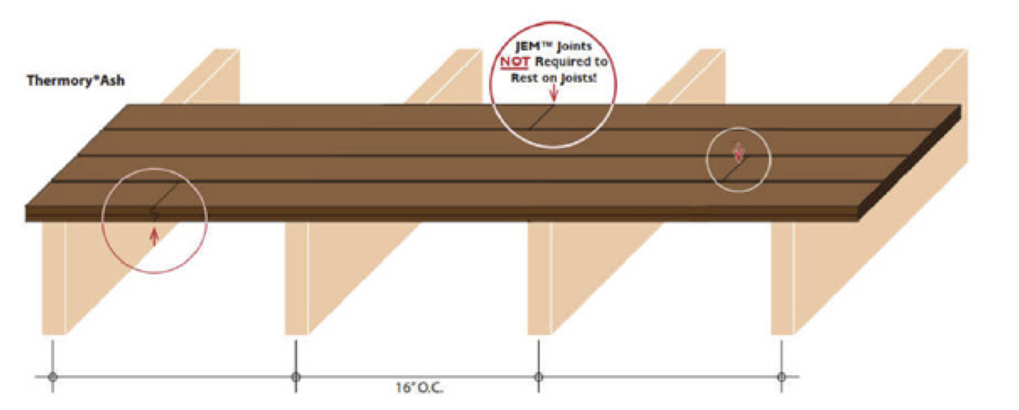
REINDEERWOOD® ASH DECKING INCLUDES JEM™ JOINTS
Reindeer wood
JEM™ Joints NOT Required to Rest on Joists!

With Reindeerwood® exclusive JEM™ Joint (joint end matched) the ends of the boards do not need to rest on the support joists. Each board must rest on and be fastened to a minimum of two joists.
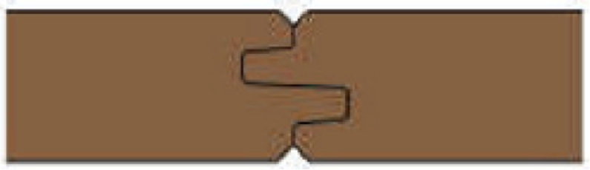

To lengthen the life of joist and prevent wood to wood contact, the use of joist tape such as Imus Seal Butyl Joist Tape is highly recommended.

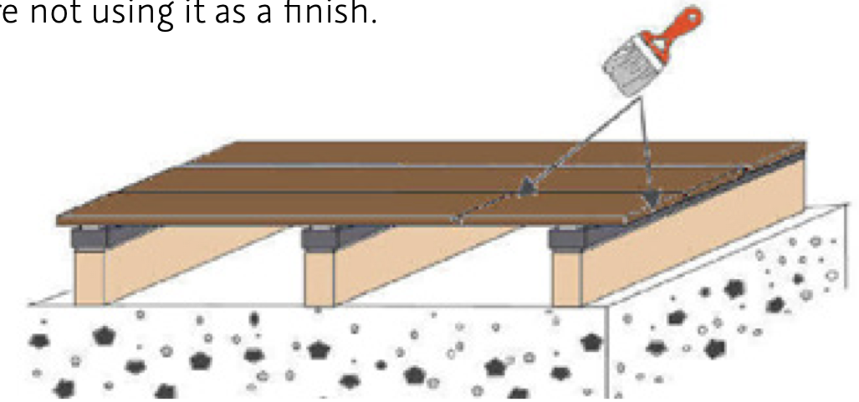
End Sealing – Although Reindeerwood® is much more stable than any other wood product, it will still take on and give off moisture through the exposed end grain of the boards. When this happens too quickly, large end cracks may develop and there is a risk of end splits. To reduce these end cracks we recommend using Cutek Extreme on both ends of each board before they are fixed in place even if you are not using it as a finish.

Steps must be face-screwed (do not use any hidden fasteners). The front edge of the step is
always more susceptible to splitting or cracking. The possibility of this can be reduced by not cantilevering the edge of the step over the riser by any more than 3/4”. The radius on the top front edge of the step should be rounded to a bull-nose and 5/4 material should be utilized.

Kodiak Spruce decking must be installed brushed side up as the reverse side is pith and cannot be exposed.

Maintain 1/8” gap between deck boards up to 4” in width and 1/4” for deck boards over 4” in width.

Be sure to set the power drill’s clutch at the appropriate setting. The head of the screw should sit flush with the surface of the board. However, over-tightening can strip the fiber of the wood joist.
Face screw the outside edges of the first and last decking boards using stainless steel screws.

Reindeerwood® recommends the use of Fixing Group Solida 1 self-tapping, stainless steel trim head screws which can be purchased with your Reindeer wood® decking.

Always use stainless steel screws, never nails, when installing Reindeer wood decking. If face screwing while using stainless steel screws other than the recommended Sihga® or Solida 1 screws, we recommend pre-drilling a hole that is 1/32” smaller in diameter than the screw. The screw head’s taper must be countersunk as well. We recommend the utilization of a depth stop. The size of the screw head must match the size of the countersink.

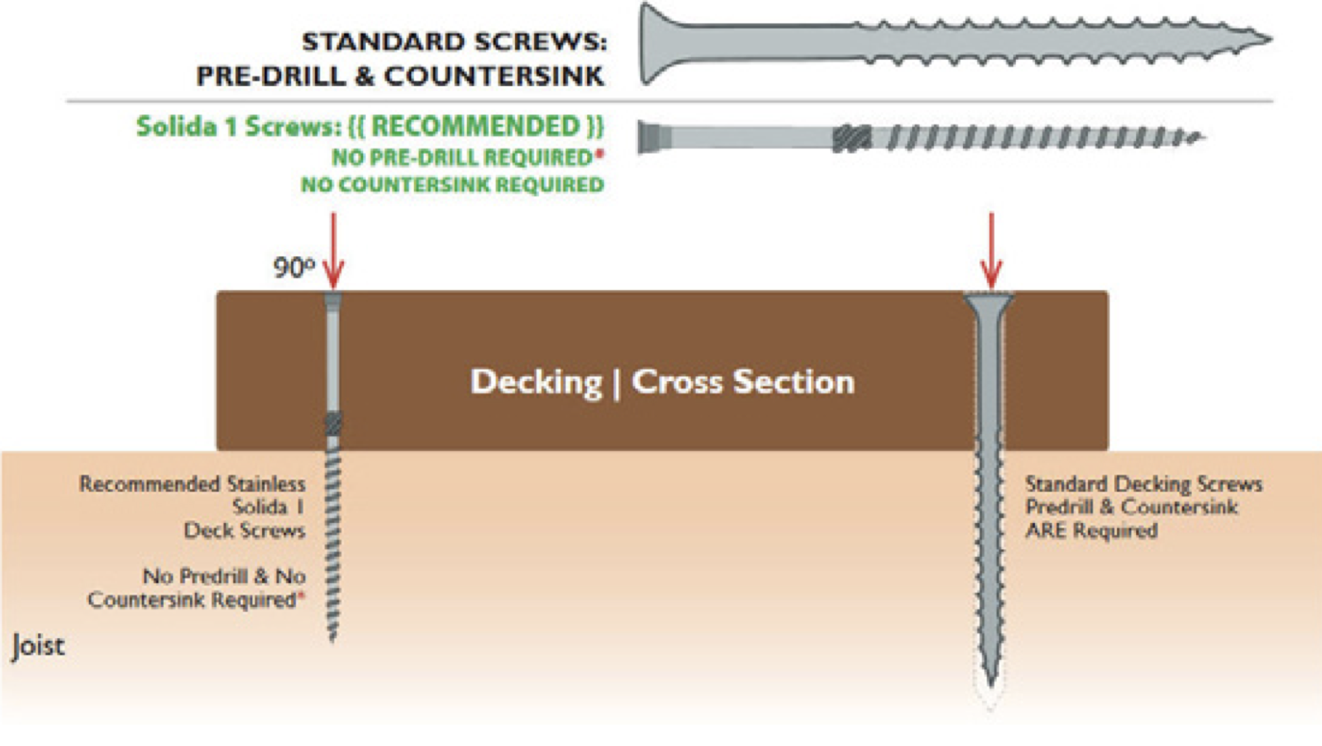
REINDEERWOOD® ASH DECKING INCLUDES JEM™ JOINTS
STANDARD SCREWS:
PRE-DRILL & COUNTERSINK
Solida 1 screws: (( RECOMMENDED ))
NO PRE-DRILL REQUIRED*
NO COUNTERSINK REQUIRED

Minimum screwing distance from edge: 3⁄4”. Minimum screwing distance from end: 1 ½”.
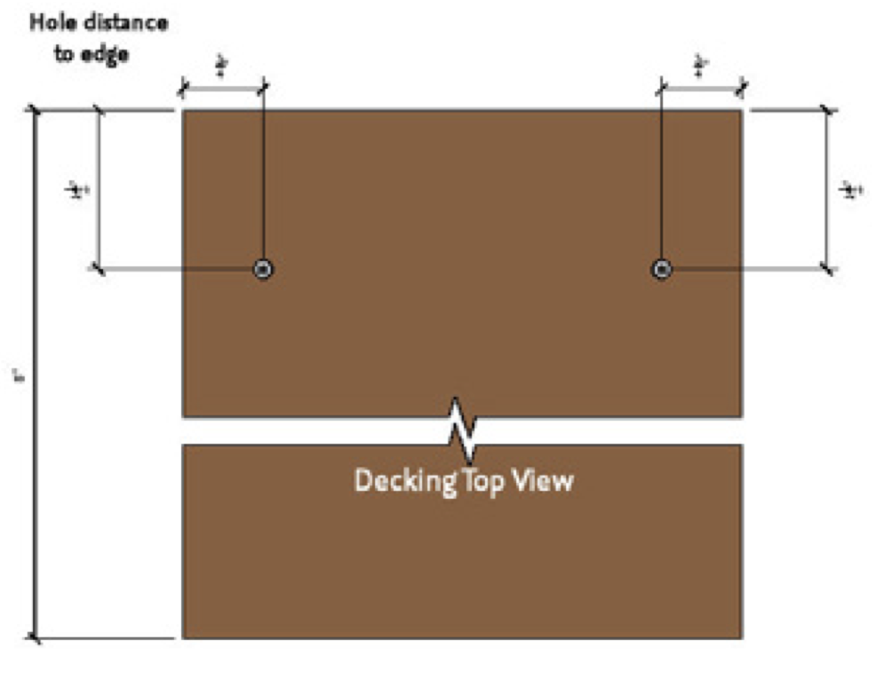
Pre-drilling is required, even with recommended self tapping Fixing Group Solida 1 screw, less than 8” from the end of deck board.
Hole distance
to edge

Reindeerwood® Hidden Clip System automatically provides the proper gap between deck boards. T4 clips for 1 x 4 and 5/4 x 4 Ash, T6 clips for Ash decking 5” and wider, and PC clips for Pine and Spruce decking.

One clip is required on each joist.

Do not over tighten screw as it can cause excessive squeaking or damage the clip itself.

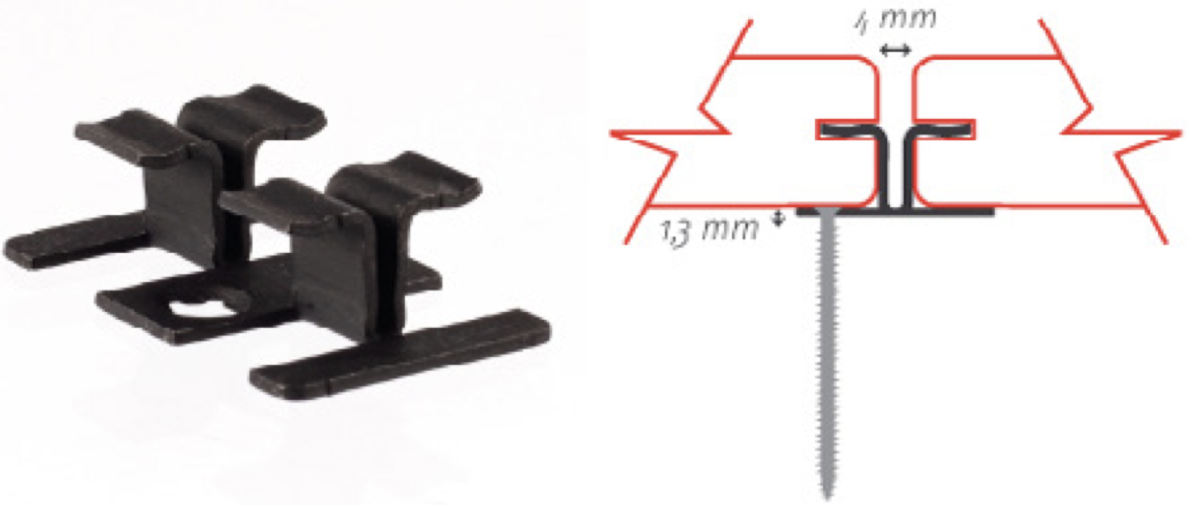
T4 CLIP- ASH 4” GROOVED DECKING PROFILES ONLY

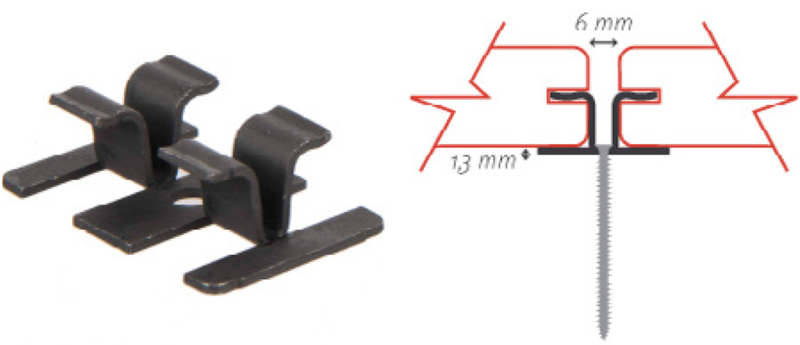
T6 CLIP- ASH 5” AND WIDER GROOVED DECKING PROFILES

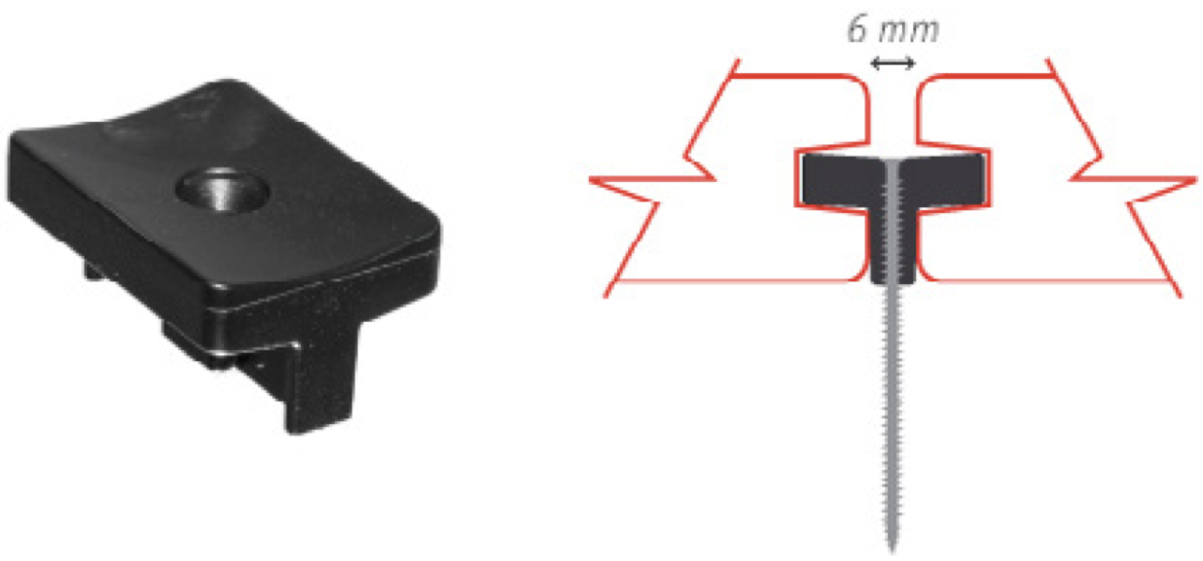
PC CLIP - ALL PINE AND SPRUCE GROOVED DECKING PROFILES
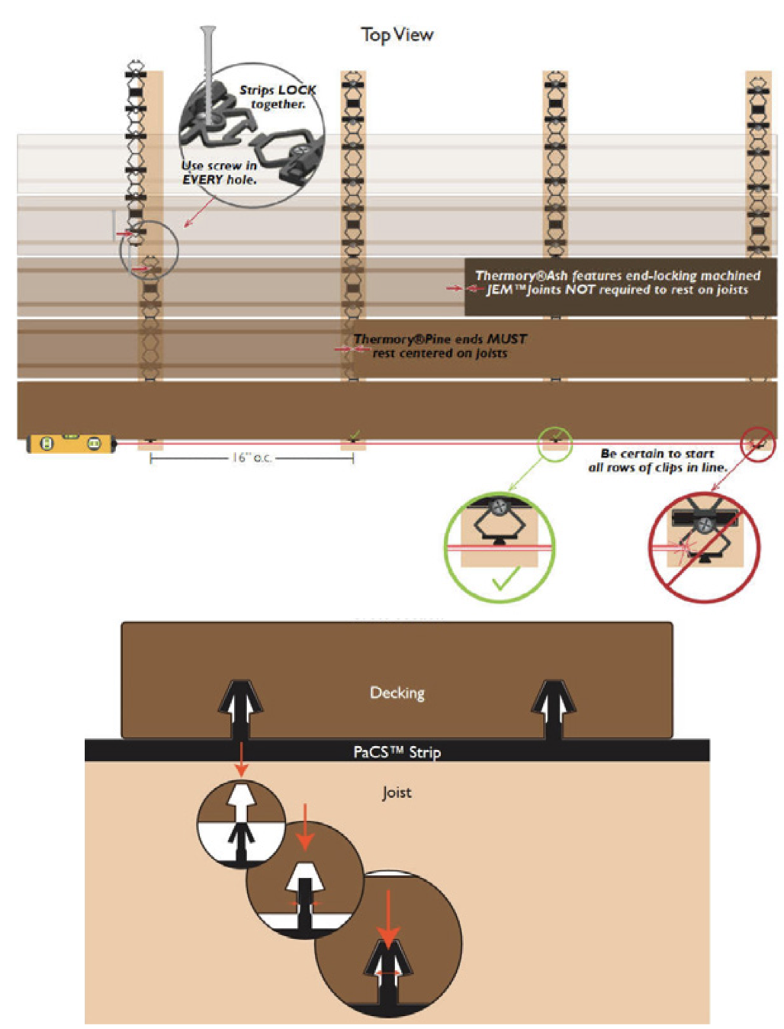

CALCULATING THE QUANTITY OF PaCS™ STRIPS NEEDED

Decking with 16” on center joist spacing: 48 sq.ft. per bag (includes screws).
It is essential that air can circulate under the decking, allowing the relative humidity above and below the decking to fluctuate evenly and be equal above and below at any given time. Do not trap moisture beneath the deck.

Example: For roof decking and pool side applications, the pitch of the subsurface must be
at least 1⁄4”per foot with no water pooling. Ends of the deck must be left open to allow air
circulation. If wood, support joists must not sit directly on the subsurface as they will absorb
water and trap moisture below the decking. Be sure to shim the joists up off the surface with
a non-permeable shim, allowing air circulation and drying of joists/sleepers.

Reindeerwood products CANNOT be directly installed on the ground. They must be installed onto a substructure that is made into a frame. There must be an adequate and unobstructed air flow under the decking to prevent excessive water absorption. If there is excessive water absorption, swelling can occur. A minimum of 4 inches of continuous net free area under the decking surface is required for adequate ventilation, so air can circulate between adjacent members to promote drainage and drying. If you are skirting your deck make sure to have areas where air can flow through (such as adding strip vents to the fascia).
In situations with limited clearance or restricted air circulation, strong consideration should be given to using 5/4 thickness material and narrower (4” or 5”) widths (when using Ash).

TO PREVENT MOISTURE FROM ACCUMULATING UNDER DECK
Slope ground away from structure
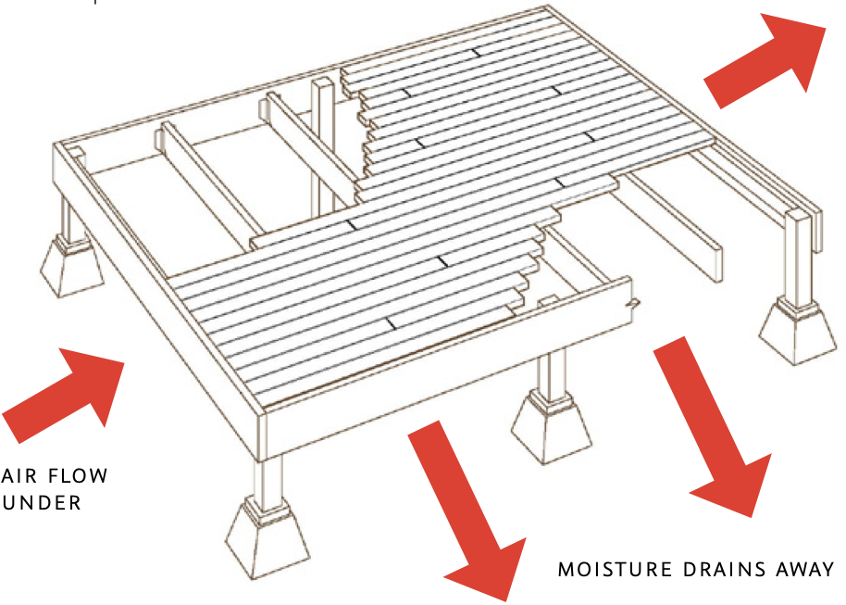
Provide drains underneath
Install strip vents in fascia
Reindeerwood® Porch Flooring is available in 4/4 Ash and 5/4 Scots Pine.

Always use Fixing Group Solida 1 stainless steel screws for fixing Reindeerwood® Porch Flooring, never nails or staples.

Reindeerwood® Porch Flooring must be used only for covered porch applications with adequate pitch to allow run-off of wind-blown rain or snow melt. A pitch of 1/8” per foot is necessary at minimum.

Note: Reindeerwood® Porch Flooring is also used for siding, soffit and fascia applications. Reindeer wood® Porch Flooring should never be used for uncovered decks.

Allow a minimum of 4” of air space beneath porch flooring. Proper drainage and air movement underneath decking and porch flooring is required. No pooling water or excessive humidity is allowed under porch. Reindeerwood® Porch Flooring should not be installed directly on top of a solid surface (plywood, concrete, etc.), joists would have to be installed to provide an air space in between.

During installation, if the tongue is splitting when screwing be sure you are using Reindeerwood recommended screws. Reduce the angle of the screw to catch wood on the backside of the porch floor board.
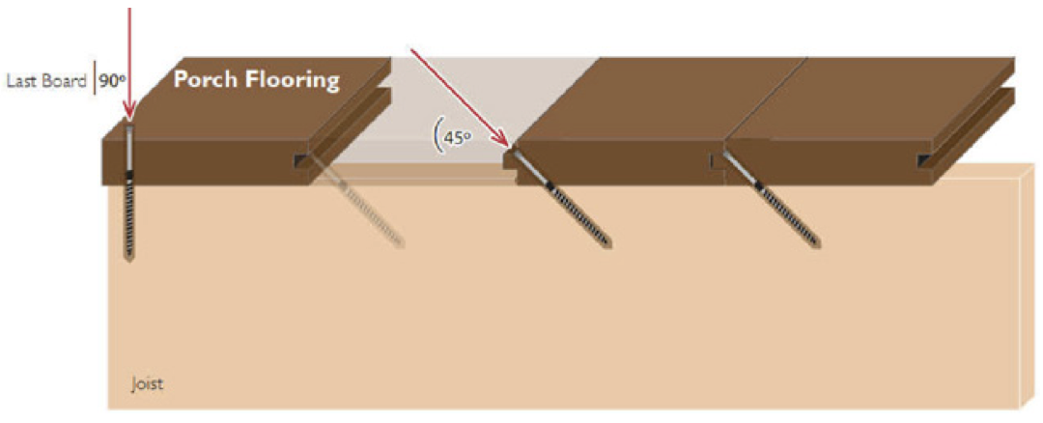
Reindeerwood is committed to providing you with a quality product that performs exactly as we say it should. Reindeerwood decking, cladding and porch flooring products are real wood which is likely one of the reasons you chose Reindeerwood. Like any real wood product, it’s not perfect. Wood products can react to their surrounding environment in natural ways that result in a less than perfect appearance. Our thermal modification process reduces common issues such as of severe cracks and moisture related movement, but will not prevent them completely. In comparable situations, Reindeerwood will always perform better than other wood products in terms of rot and moisture related movement.

If you’re experiencing issues with your Reindeerwood project, we’d like for you to read through the installation guide again to ensure that the recommended guidelines were followed.
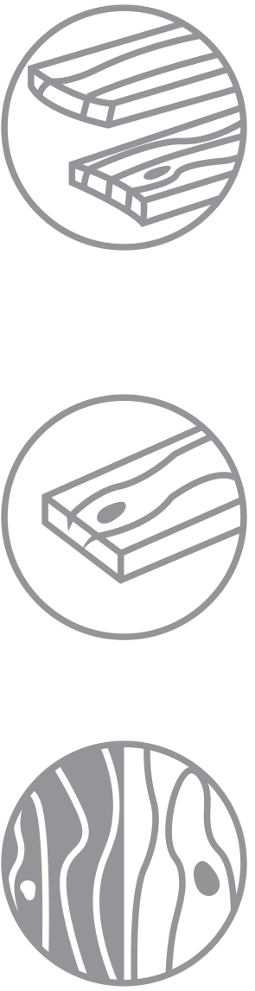
HERE ARE SOME COMMON CONCERNS AND THE REASONS FOR THE PRODUCT’S REACTION.

CUPPING & CROWNING
Most cracks or warping occur with an imbalance of relative humidity above and below the deck. When the humidity below the deck is higher than the relative humidity of the ambient surroundings, the wood’s cells on the bottom of the board will swell, causing cupping, evident when the board makes a “smiley face.” Adversely when wood releases excess moisture this causes the wood to crown and cause a “frown face”.

CRACKING
Cracking and swelling in the opposite direction is most often because the exposed surface of the wood has been finished with a “film forming” or non- penetrating oil. Film forming finishes can cause the wood to trap moisture within the fiber over time, preventing the wood to “breathe” naturally and expel excessive moisture.

COLOR CHANGE
All wood products will experience color change, even if they have been treated with a UV protectant product such as Protego or like products with colortones. The surface of wood can be considered similar to our skin. Even if we put an excessive amount of sunblock on our skin, under prolonged conditions our skin will eventually tan or burn. UV protectant will slow this dramatically but will never stop it all together. Without Protego or like products plus colortone, the color change will happen drastically faster.

The specific project application will make the speed of color change happen at considerably different rates. Decking will change in color much faster than cladding or fencing since the UV exposure to decking is more direct than cladding. Soffits and porch flooring will only turn grey when exposed to the combination of all three elements; water, sun and oxygen. When one is missing, wood may fade, but will not turn grey. Cladding will still turn grey, but at a slower rate, approximately half the rate of decking.

BLACK STAINING AT SCREW HOLES
Stainless steel fasteners are required with Reindeerwood products. Thermally modified wood has a higher acidity than non-modified wood or pressure treated wood and can cause non-stainless screws to corrode quickly. This corrosion can be seen as the chemical reaction bleeds into the grain with black staining.

CLADDING IS EXPANDING/BUCKLING OFF THE WALL
When there is an imbalance in the relative humidity on the backside of the board versus the front of the board, this will cause the wood to cup. In most cases, the boards will swell on the back side of the board which means the top edges of the board will point outward. When the swelling is severe enough, and no longer has room to expand - the boards will eventually break.

This imbalance of relative humidity happens because there is a lack of ventilation behind the cladding. There needs to be clear and open ventilation at the bottom of the wall and running the entire height, venting at the top or into the soffit. Drainage mats historically do not provide adequate ventilation and free air movement.

If you feel adequate ventilation has been observed in the installation, then there is likely a source of water behind the wall, such as poor flashing at the soffit/cladding transition or around the windows.

In most cases, if breakage has not occurred, the cladding will right itself over time if the venting mistake has been corrected. The correct ventilation, or fixing the incorrect flashing installation will reduce the moisture behind the cladding, rebalancing the relative humidity and allowing the cladding to equalize and lay flat again.

COLOR IS BLEEDING FROM BOARDS AND STAINING LIGHT-COLORED
SURFACES
There are no chemicals in any of the Reindeerwood species, however bleeding can still occur. As water, sun and oxygen engage with the surface of the wood, specific cells holding the wood’s tannin become water soluble. This tannin is what gives the wood it’s color. As rain occurs, those tannins will bleed off the surface and run down the face of a building or drip to a surface below.
This will be more apparent on lighter colors, such as stone, marble or stucco. The tannins are completely organic and will likely wash away within a
season. If nature’s process isn’t fast enough, a cleaner approved by the surface manufacturer may be used.

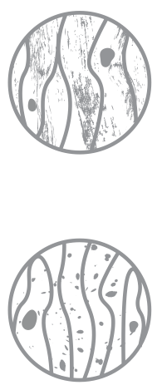

DRIFT PRODUCT LINE
Drift products, such as Platinum and Black Pearl have a light finish applied and are intended to be an alternative to the look of reclaimed lumber. Over time, the initial coating on Drift will weather, exposing the thermally modified fiber beneath. This fiber will eventually take on a natural silver patina, ensuring
an old-world reclaimed look that will endure for many years with minimal maintenance.

BLACK AND/OR GREEN SURFACE STAIN AND MOLD
Black surface stains are caused by dirt, debris, pollen and other airborne and microscopic elements resting on the surface of the deck. Certain environments provide exceptional growing conditions for mold and fungus, conditions that often fall within, but are not limited to shaded decks or cladding. The black or green staining you are experiencing is likely this mold and fungus.
This is not a cause for concern, but it does mean you should be clearing
the surface of your deck more often and taking additional preventative care considering surrounding conditions. It is important to remember the same occurrence can happen on any surface, such as rocks, glass, PVC, and composite products.

This staining is removable with light pressure washing and a renewing/cleaning agent. Cutek is the Reindeer wood recommended product line and you can find cleaning options on Protego.

With proper installation and maintenance your Reindeerwood product can perform well, but as with anything else in life there are always mishaps that can happen. We are here for any problems that may arise with your product and want to make sure you’re satisfied while understanding the natural occurrences that can happen to real wood products.

